BREADALBANE ACADEMY PARENT COUNCIL
Communications Survey – Report on main findings
November 2015
- Introduction
The Parent Council decided in May 2015 to undertake a survey of all parents/carers on school communications. This was in response to feedback from parents, primarily through the Parent Council and over a period of several years, that communications were inadequate and having a detrimental impact on the pupils and the whole school community.
Representatives of the Parent Council worked with the school management (Headteacher John Devine and Depute Nicola Ross) to develop the survey and in presenting the results. We are grateful to all those who have worked with us to prepare, run, publicise, respond to and analyse the survey.
We are also grateful for comments and feedback received outside the online survey. We have reflected these in the report where they raised important points not raised by online respondents. The remainder of the comments received outside the survey provided helpful additional background, evidence and more detailed suggestions that will be taken into account/shared with the school in summary form to assist its response to the survey.
Any comments or feedback provided in the survey which did not relate specifically to communications but which we felt were important for the senior management team to be aware of were forwarded to the school in summary form.
We hope that the Parent Council will continue to work with the school management on developing and implementing its response to the survey results through a school communications strategy. This report presents the key findings from the survey. The list of survey questions is provided in Annex 1.
- Key findings
General
Profile of respondents
- The survey received a good, representative sample of parents and carers. Altogether, there were 96 responses out of a potential 558 households, or 17 %. The profile of responses provide a good representation of the school population, with 55% with children in primary, and 60% in secondary; and 61% local to Aberfeldy, 32% further away.

- In Figure 1, each coloured line shows the distribution of parents' answers for a single question. The lower the score, the better the parents' experience of school communications. But with few exceptions, the lines bulge over the centre of the scale, indicating that most parents had a middling rather than a good experience.
Figure 1: Statistical analysis of ‘agree’ questions 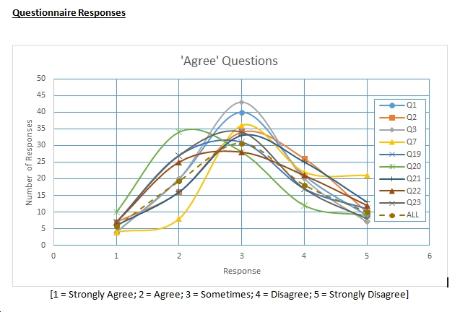

- Positive feedback – general
Several positive comments were made about communications in general:
- ‘Pleased to see school actively taking on board parents views’
- ‘Commend efforts of the Parent Council to raise awareness through its Facebook page’
- ‘School generally receptive to attempts parent makes to communicate’
- Some have had good experiences with staff/guidance teachers responding to issues and concerns.
- There is a perception that there has been an improvement in responses to emails and phone calls since the new headteacher has been post.
Communications from the school
General
- There is a clear view from parents that there is a need to improve communications, with 70% being dissatisfied or very dissatisfied with communications from Breadalbane Academy (see figure 2).
Figure 2: Overall satisfaction with communications

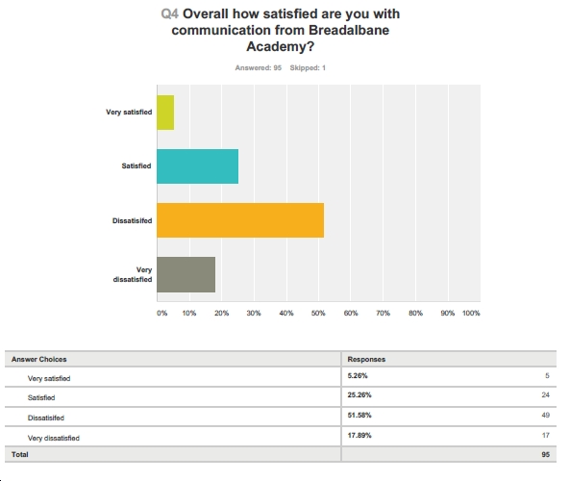
- When given the option of ‘sometimes’ to questions about communications, this was the most popular response (about 40%), indicating that communications are inconsistent and patchy, giving parents/carers a mixed experience. For example, for the question “the school keeps me up to date with my child’s learning” 42% said sometimes, with 31% disagreeing, and 28% agreeing.
Means of communication
- Responses show that a variety of communications are expected and needed to suit the particular need or circumstances (see figure 3).

- Groupcall texts are viewed as very useful, but only appropriate for brief, generic messages or alerts. In other cases, contact by telephone/face to face is desired, and should always be available to parents/carers. The school should be aware that there can be issues with mobile coverage, so Groupcall texts cannot be counted on to reach everyone, or without delay (important where the information being sent relates to cancellation of after-school activities, or to transport etc). Also, some parents/carers prefer letters home rather than receiving the information electronically. Parents/carers thought Twitter was the least useful means for communication.

Figure 3: Most useful sources of information - future
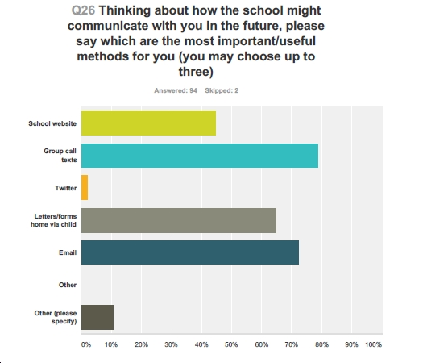

- Parents/carers highlighted other methods of communication, namely local meetings, posters, Facebook, and homework diaries. Other suggestions and comments included:-

  - Email newsletter: A regular newsletter, pulling together relevant information for parents sent via email (and with link on the website) would be helpful. This helps parents as not everyone can or wants to keep up to date with all the various social media channels to find information or stumble across it by chance on the school website. This ‘news feed’ could be subscribed to by parents. When looking at the survey responses as a whole it was clear that there is strong interest in email communication – it was mentioned as helpful/desirable at least fourteen times.

  - Website: Some respondents find the website ‘hard to navigate’ and believe it ‘needs a significant upgrade so it can be used as a daily source of information’. Others noted that the website is out of date, and lacking a general contact email address. One person commented that the Twitter feed seems to be ‘used as a substitute for a better website’. An interesting suggestion (outwith the online survey responses) was that web design, build and maintenance could be a valuable project for pupils wishing to develop their skills and experience in this area.

  - Home school diary: This is seen as useful but should not be a ‘substitute for face-to-face contact.’

  - Parent rep system (primary) may be unreliable as many parents are not willing to pass on their contact details

  - Information evenings (in addition to Parent Council meetings) to introduce topics such as the transition to senior years.
Content, accuracy of information, tone of communications
- Respondents commented that communications, in particular letters, should be improved in terms of accuracy (eg dates, times), clarity (eg if there is a meeting or open evening at school are children to come with their parents or not?) and tone (some letters could be more polite and less brusque).
Timeliness
- Nearly half (47%) of respondents said they did not receive information when they needed it (with sufficient notice), with 40% saying they ‘sometimes’ got it ‘with plenty of notice.’ This leaves only 12% agreeing that communications are timely (see figure 4).

- Comments reflect this concern: ‘Communications can often be late, even after the event or with too short notice if parent needs to organise or supply something, or might want to support eg a sporting event.’ ‘Texts come in too late/after an event (eg bus running late or school closure after children have set off)’.

- This concern also applied to telephone communications: ‘School is very slow at returning calls and queries and it often takes several attempts to get an answer.’ And there is ‘a sense there is a lack of urgency to deal with parent concerns or queries.’ A failure to respond, or delay in responding, was mentioned at least 12 times in the survey. The need for office staff to understand the relative priority/urgency of calls/requests from parents was mentioned by one respondent as vitally important to avoid negative consequences – this being based on personal experience.
Figure 4: Timeliness of communications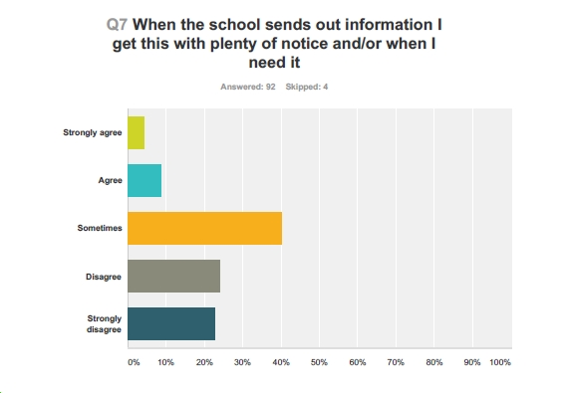
Frequency
- Respondents expressed a desire for more regular communications. Frequency will depend on what is being communicated, but in all cases it needs to be with enough advance notice for parents/carers to respond. One notable comment was that: ‘information comes through sporadically with no real organisation or set format.’

In terms of a newsletter with general information, the majority (60%) favoured a monthly newsletter, with 20% preferring weekly, and only 12% wanting it termly (see figure 5).

There was also some interest in a weekly parents' bulletin. This could be available as a quick download on the home page of website, covering important news for the week ahead, such as events, things to remember etc, as well as recognising recent successes for the school and individuals. This could be supplemented by a ‘glossy’, colourful newsletter including articles by pupils on a termly basis.

- Other suggestions included changing parent contact nights to twice a year.

Figure 5: Frequency of general newsletter

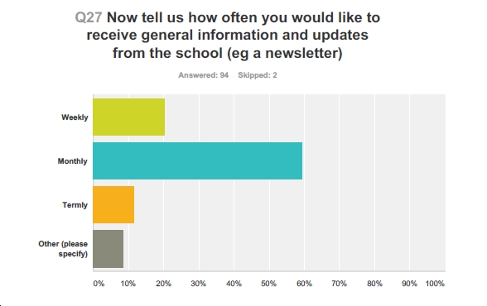

What information people want
- Not surprisingly, parents/carers thought all types of information presented in the survey were important, with the following receiving the highest ratings:-

- Updates on my child’s progress - 93% saying it was very important.

- Information about what my child is learning and how I can help – 80% very important

- Information about homework – 72% very important

- Early notice of events, school trips – 76% very important

- The other options on the survey followed close behind and were also rated important or very important. These are: information about school clubs, support for pupils and parents, school policies, recognition of successes, school progress, and curriculum. This suggests that all these themes are seen as worthy of good communications.

- “Other information” people would like to see:-

  - Year-ahead calendar of events/activities/school trips/sports events/parents’ evenings/social events/Parent Council meeting etc sent out at the beginning of each term with updates on website. There is strong interest in receiving a calendar for the year ahead – mentioned on at least six occasions in the survey.

  - Briefing on transition from general (S1-3) to senior years (S4-6) and early information about selecting courses, how it works, implications for exams etc.

  - More comprehensive handbook for new parents (updated/circulated electronically and on the website for pupils beyond P1/S1).

  - Contact details for key people: class teacher (primary) or support teacher (secondary) and directions on how to get in touch with people directly. This information should be provided termly with a reminder about who to contact about what. Overall responses to the survey showed clearly that parents were unclear about who they should contact, depending on the issue, or wanted greater clarity over this (mentioned as an issue on nine occasions).

  - Improved information for parents of children with additional needs – how they are supported, updates, and how children with behavioural issues are managed.

  - A full list of teachers in each subject kept up to date on the website and emailed out (twice a year). Notification of changes in staffing provided in advance.

  - In primary, a letter of introduction from the class teacher at beginning of the new session outlining what kids are supposed to do for homework (format) and rules of classroom, targets, events etc. Also a termly outline of what topics they will be doing, extra-curricular activities etc.

  - In secondary, a letter from each teacher outlining what will be achieved in each year group and in each subject. (eg the new French 'Le Passport' for S1 and S2 which outlines what they are doing and have done was flagged up as good).

  - More information on school walls (accessible to parents) about what is going on in school, achievements, successes etc. The school needs to “sell itself” to parents and make parents feel part of the school community.

  - Shadowing and work experience opportunities.

  - Feedback received outwith the online survey responses highlighted issues about communication with parents in relation to confirmation of school places for people moving into the area, also clearer information about/promotion of Gaelic medium option, better “welcome pack” and communication around “settling in sessions”, uniform, the house system, the need to register early for after-school clubs which have a waiting list etc.

Communications from parents to the school
- There was a mixed response in terms of how satisfied parents/carers were with their ability to communicate with the school. One-third said they were sometimes satisfied (33%), with 37% agreeing and 30% disagreeing (see figure 6). As with communications from the school to parents/carers, this reveals inconsistency and gaps in the school’s performance and implies that parents/carers are not confident in their ability to communicate with the school when they need to.

- Respondents report varying experiences of attempts to communicate (eg “school communication is good when it's about buses, photos etc”) but there were seventeen references that can be grouped under the heading “poor experiences of attempting to communicate with the school.” The wording of these comments leaves no doubt that many people have had very negative, frustrating or concerning experiences.
Figure 6: Overall satisfaction with ability to communicate with the school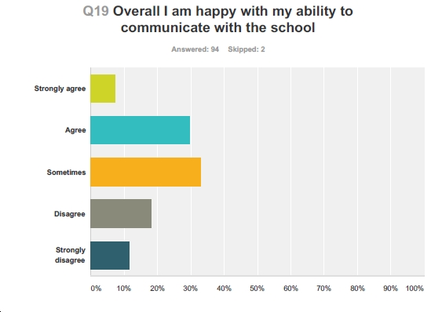

The key themes that emerged were:-

Procedural/administrative issues:
Emails/phone calls

- Lack of response to/acknowledgement of emails and letters; need to chase for replies; a feeling that communications get lost between office and staff. People would like an acknowledgement that their email got through. A lack of, or slow response, by the school to parents’ communications was mentioned explicitly at least twelve times.

- Parents/carers are concerned that emails sent to the school office are not forwarded and/or get lost. The same concern applies to phone messages (do not get through to the person concerned or are ignored and calls are not returned).

- Concerns over confidentiality of emails sent via school office – there are times when parents/carers need to contact a teacher directly and this is currently very difficult (this also makes people feel that school is not very approachable/open to communication).

Knowing who to contact

  - Uncertainty over who to contact about what and how (eg after school clubs or even simple things like child being late because of dentist). This was mentioned explicitly at least six times.

  - Lack of clarity about how to contact support staff in secondary.

  - More clarity needed on how forms should be sent back to school and to whom.

Office issues/internal communications

- Concern there is poor communication between the different services within the campus and with the campus owner/manager. There is a lack of information on lines of responsibility within the campus.

- Communication around staff changes has been poor.

- Difficulty (or failure) of school to recognise more challenging communication issues eg where parents have separated.

- Some parents reported that office staff are not always well-informed and keep parents waiting while they try to get the answer. There was a feeling that office staff needs to better understand the relative priority of issues raised by parents, otherwise delays in dealing with urgent requests can have negative impacts on young people’s education and opportunities.

- One parent commented that children had reported that staff on reception/in the office could be unhelpful when pupils request information from them, and other parents reported experience of rude/unhelpful staff on reception and a feeling that office issues are letting the school down.

Confidence in the school being interested in/respects parents’ views

  - Difficulty in knowing how to express concerns or pass on positive feedback about school management or teachers.

  - Difficult to know how to make suggestions on how things could be improved.

  - Concern school does not take parents’ concerns seriously and has a “we know best/them and us” attitude to contact with teachers.

  - Concern at the lack of opportunities to talk to teachers directly (eg communicating questions via a homework book feels as if parents actively discouraged from having a conversation with teacher).

  - Concern that by the time parents’ night comes around it is too late to deal with problems identified at that time – parents need to be made aware of the issues sooner.
Methods

- Responses indicate that parents and carers wish to be able to use a variety of means to contact the school, depending on the situation and their own circumstances. People want a variety of communications options to cover both urgent and less urgent issues. The least favoured means is a message via the website or online forum (see figure 7).

Figure 7: Methods of contacting the school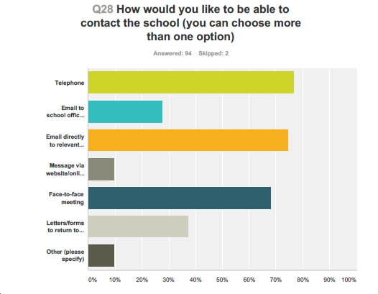

Other comments included:-

- Contact with staff: Several parents suggested direct email contact with staff rather than through third parties would be effective for communicating a range of issues and information. One said, ‘Ability to make direct email contact with teachers could save office staff hours of time dealing with parent calls and would allow staff direct, immediate contact with parents, avoiding delay and misunderstanding.’

- Suggestion box at reception and on the website.

- Face to face meetings if emails or telephone are not sorting the problem.

- There was a cautionary note regarding the parent rep system (primary) as many parents are not willing to pass on their contact details.

- Parent Council social functions are great for improving communications and a sense of community – there was a desire to see more of these.

- Conclusions and recommendations

- The survey results clearly show that there is a real need to improve communications from the school to parents/carers, and to improve the ability (and confidence) of parents/carers in communicating with the school. Comments reveal some several examples of good practice, but overall the experience is mixed, leaving parents generally dissatisfied with communications and feeling that the school cannot achieve its potential (nor the pupils) without addressing this issue. Already, some improvements have been noted, with attempts to update the website and the publication of an autumn newsletter. These were welcomed by respondents.

- The survey results, and this analysis, provide a useful starting point to inform a comprehensive communications plan that can address the needs of parents/carers and pupils and the wider community. This survey could be repeated on an annual basis to assess progress.

- The main themes which emerge are:-

- Timeliness and frequency of communications.

- Reliability, consistency and confidentiality of communications.

- An up to date ‘tool box’ of communication tools to suit the various needs and circumstances.

- There are many suggestions as to how to improve communications both from the school to parents and carers, and to help parents and carers in communicating with the school. The main suggestions are summarised below, but there are many more in this report (and in feedback/suggestions given outside the online survey) that are of equal merit:-

- A regular and frequent newsletter (at least monthly).

- An improved website.

- A yearly calendar on the website, updated regularly.

- The use of email for general school communications.

- More clarity of whom and how to contact for particular issues.

- More opportunities for direct/email contact with teachers.

- Clarity on office procedures for responding to emails and phone calls.

- The level of response to this survey shows that parents and carers are eager to know more about the school and their child’s education. This enthusiasm should be encouraged through good communications, leading to greater parental involvement and ultimately more positive outcomes for the pupils.

November 2015

