BREADALBANE ACADEMY PARENT COUNCIL
Meeting Agenda
Tuesday 1st May 2018
6.30 - 8.30 Breadalbane Community Campus

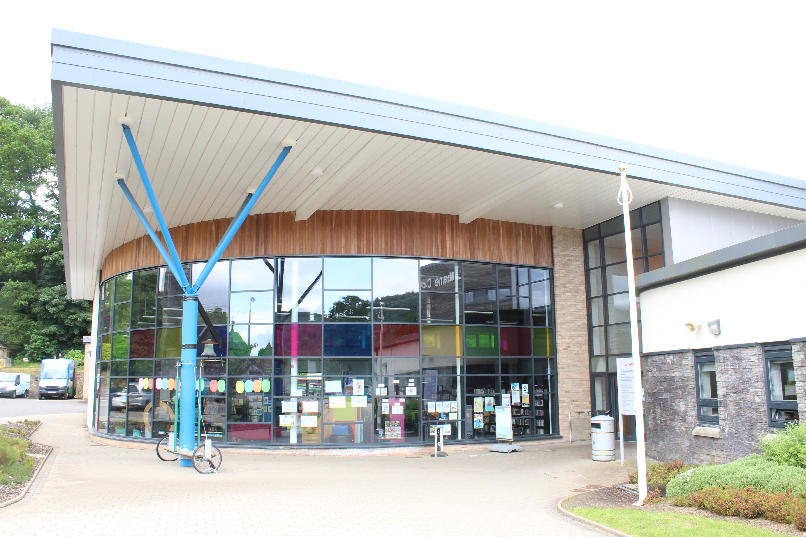
- Welcome to all and apologies
- Minutes of last meeting
- Financial report
- Headteachers report
- Friends of Breadalbane update – constitutional changes, committee, child protection.
- Safety, speed and travel plan in Aberfeldy update
- New Chair and Secretary for Parent Council
- Fundraising end of term celebration
- AOCB
- Date of next meeting – AGM - Wed 30th MAY 6.30 Breadalbane Community Campus.

